Braille Chart

Braille is a tactile writing system used by people who are blind or with impaired vision. It is traditionally written with embossed paper. Braille is named after its creator, Frenchman Louis Braille, who lost his eyesight due to a childhood accident. In 1824, at the age of 15, Braille developed his code for the French alphabet. He published the first version of his system in 1829.

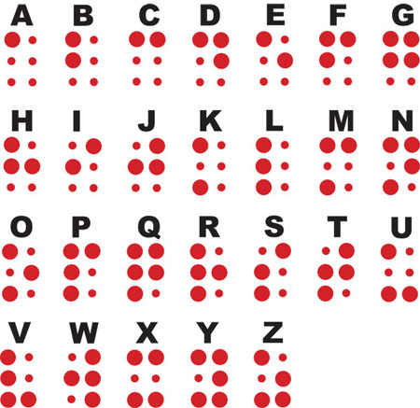

Text adapted from Wikipedia. Image source: Wikimedia Commons.